

**FPT ACADEMY INTERNATIONAL**

**FPT – APTECH COMPUTER EDUCATION**

**USER GUIDE FOR “ORIGAMI FOR ALL” WEBSITE**

**I. System Requirement**

|  |  |  |
| --- | --- | --- |
| **No** | **Software** | **Description** |
| **1** | **Operating system** | **Windows 10 or lower** |
| **2** | **Hardware** | **Intel Pentium 4 processor or higher**  **512 Megabytes of RAM or higher** |
| **3** | **Software** | **Visual Studio Code, Dreamweaver** |
| **4** | **Web browser** | **Microsoft Egde , Chrome, Firefox** |

1. **Introduction and website installation**

- This document is created to guide users use the website – “Origami for all” effectively. It is advisable that users should read this document before starting to use this website in reality.

- To run“Origami for all” website, users need to do the following steps:

* + - 1. Download the file rar *eProject – Origami for all (FPT Aptech HCM)* via this link:
      2. Extract the file rar: *eProject – Origami for all (FPT Aptech HCM)*

1. Open the folder *eProject – Origami for all >> eProject*
2. Open *Home.html* file to start the website. Look at figure below for illustration

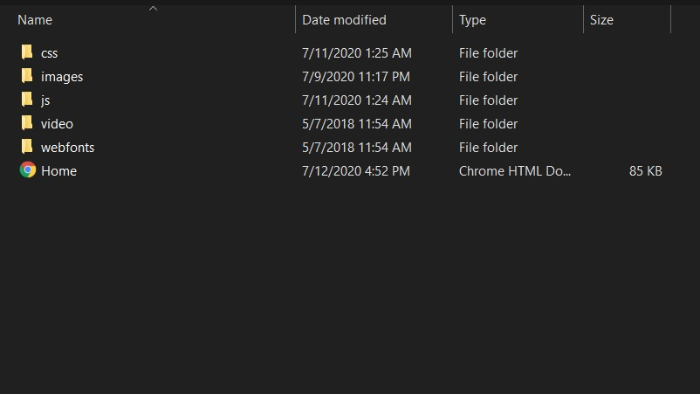

1. If done successfully, users will see the Homepage like figure below

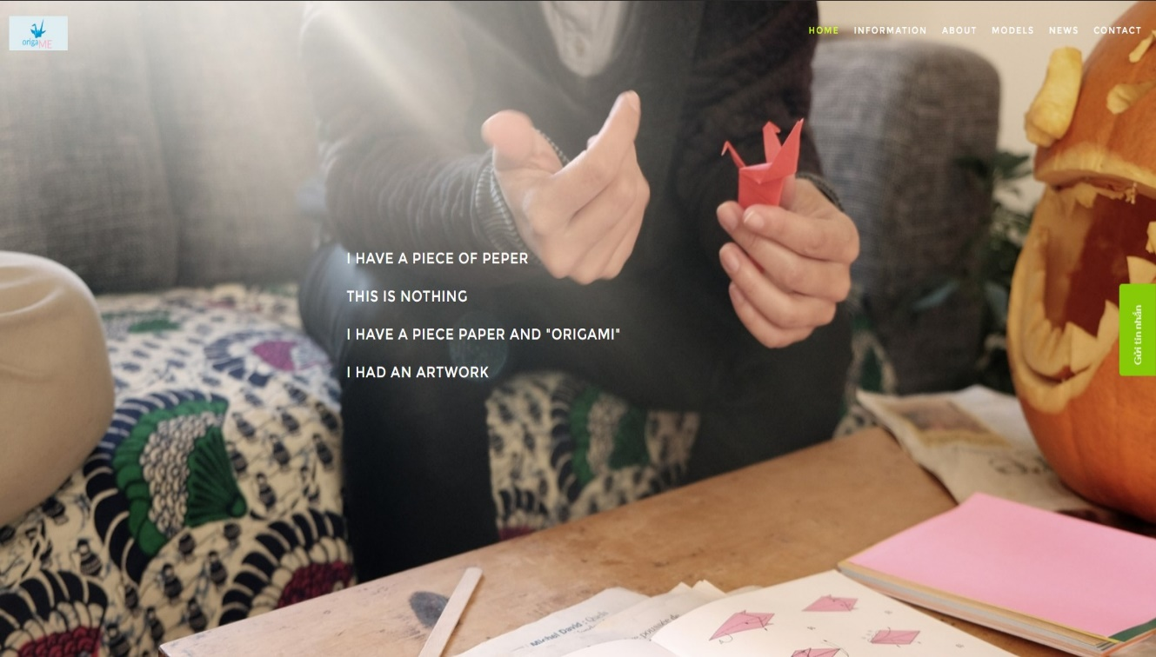

**HOMEPAGE**

**Description:**

This webpage displays following information: LOGO, Menu bar: home, information, about, models, news, contact, sologan and The chat bot of origami followings below.

**Screenshot:** 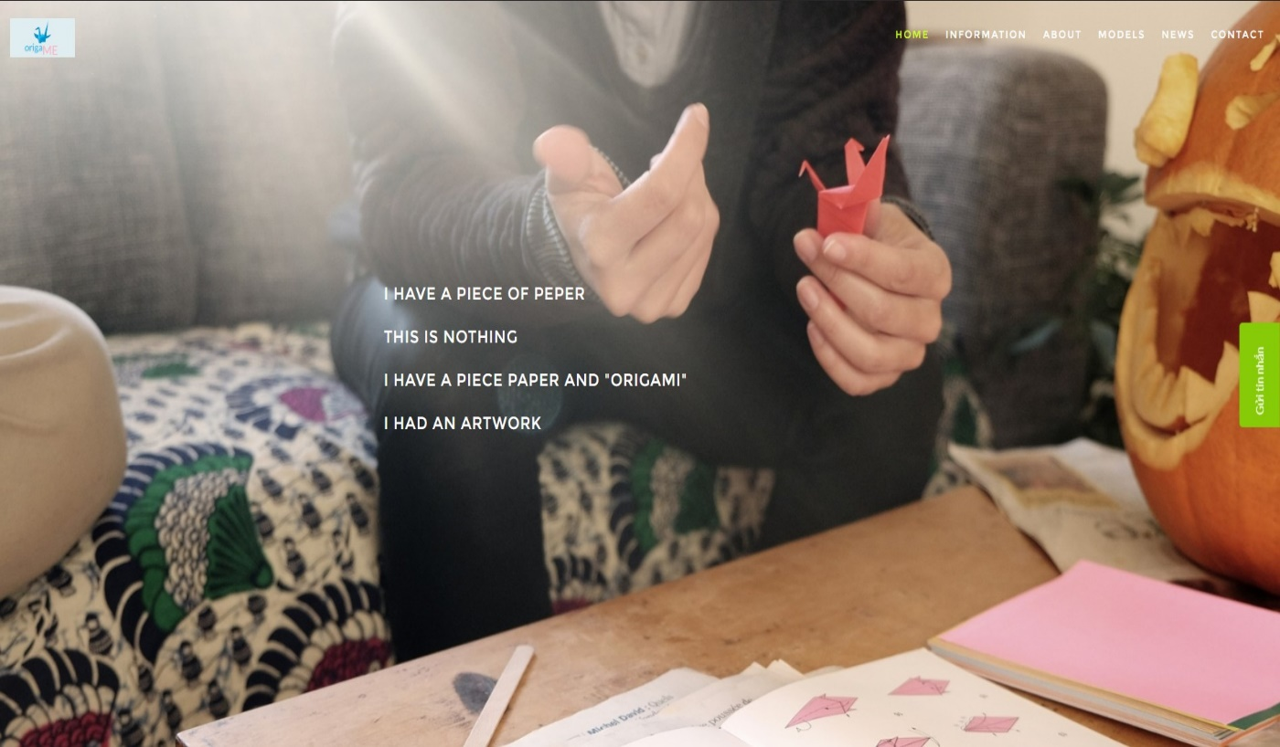

**INFORMATION**

**Description:**

There are some informations bellows in this task. It is including: introduction, original, techniques, symbolize, the importance of origami and most popular.

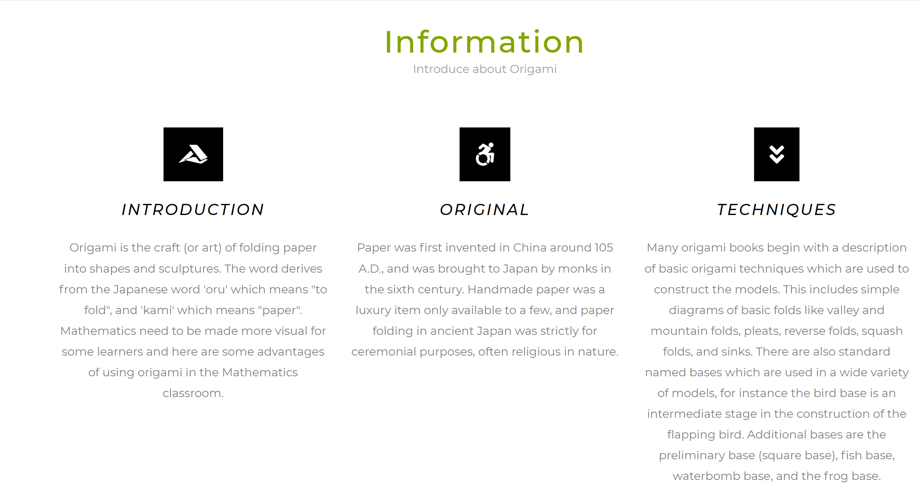

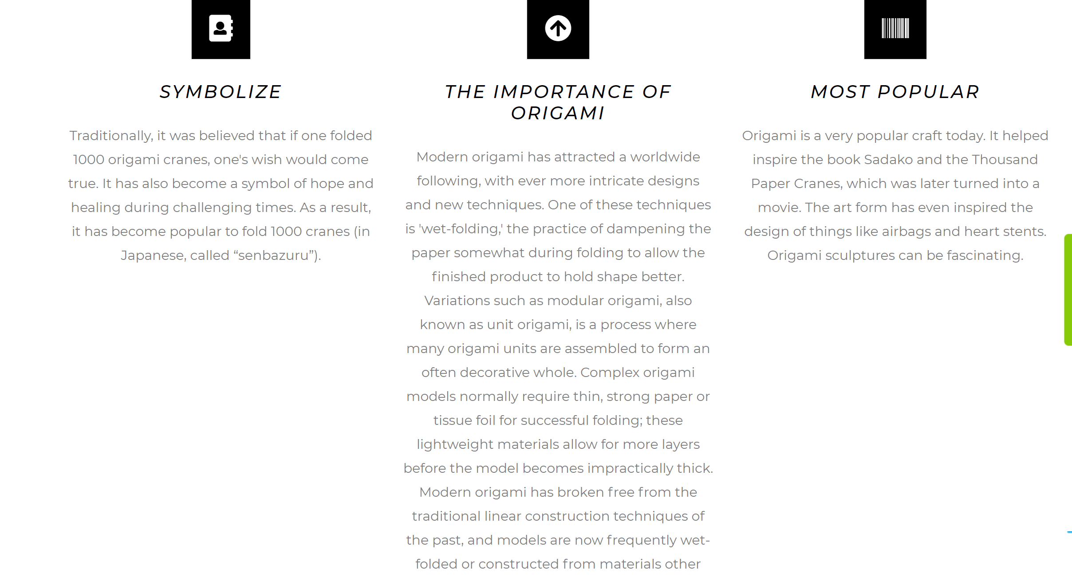

In this part, the users can know more about the details of information about art origami. They can demonstrate this kind of art – paper folding.

**ABOUT US**

**Description:**

About us we talked about the how to approach the problem, how to build and develop ideas. Another, we talked more about the principles and purposes.

**Screenshot**

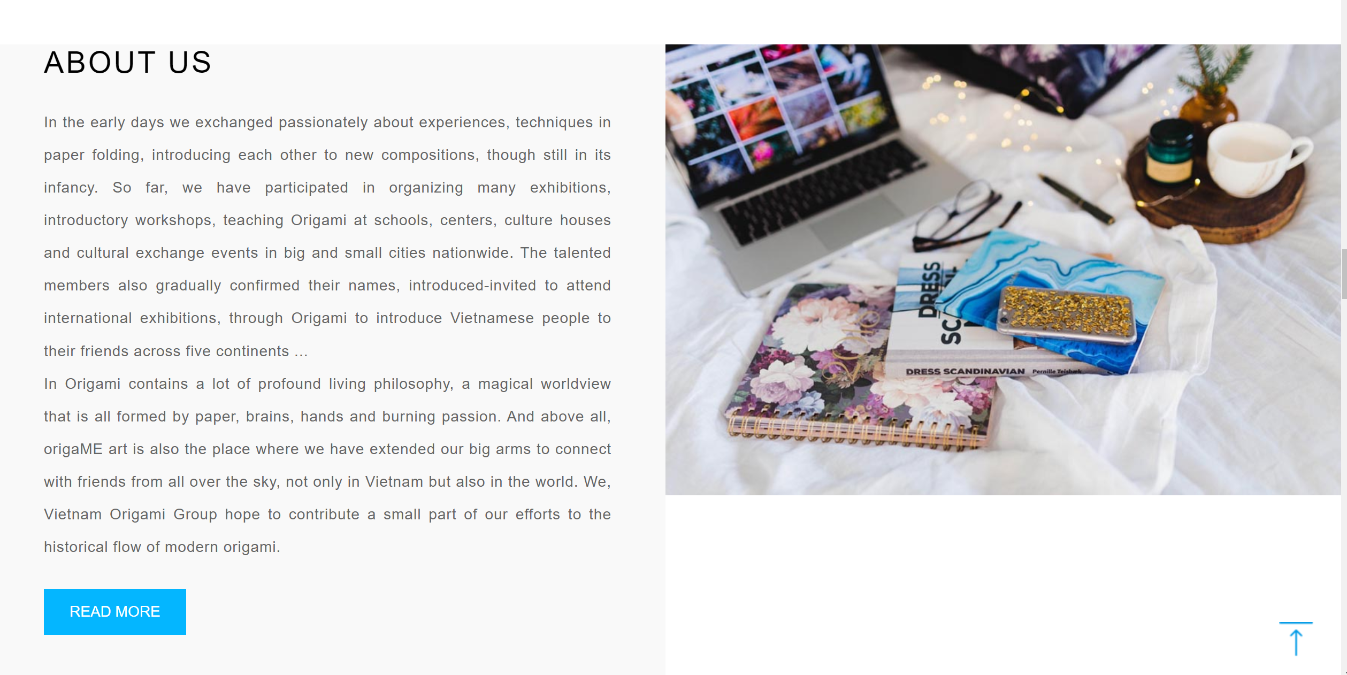

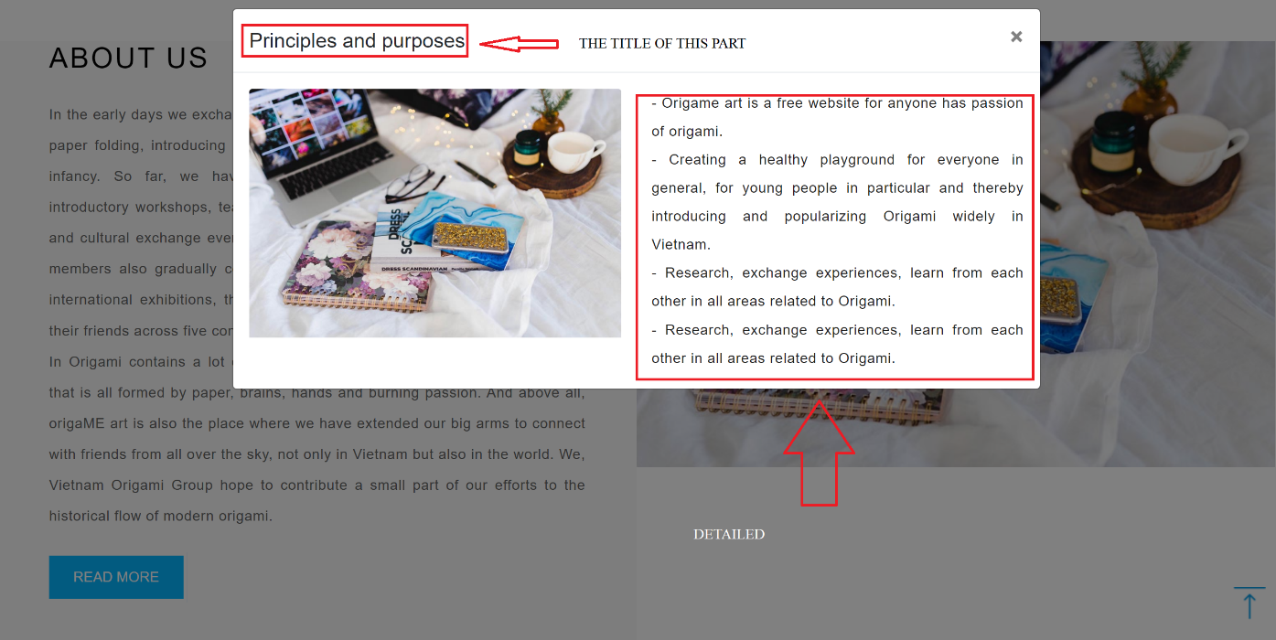

**MODELS**

**Description:**

In this models section, we talk about origami images from basic to advanced. In models, we divide it into different components like animals, action, modular, decorate.

When clicking on an object that you want to fold paper, it will appear a link to youtube describing how to fold.

**Screenshot**

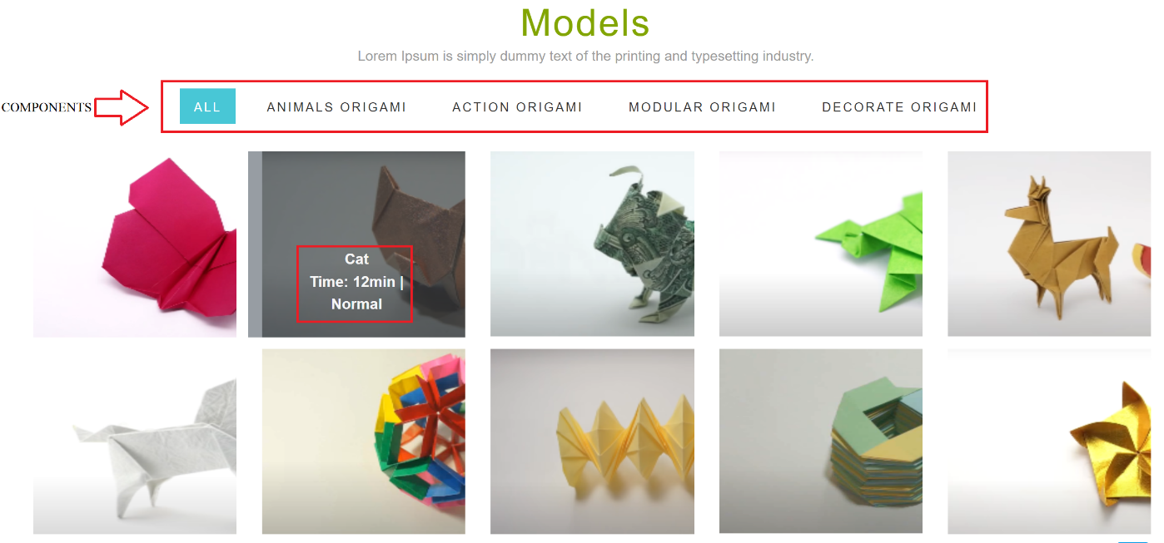

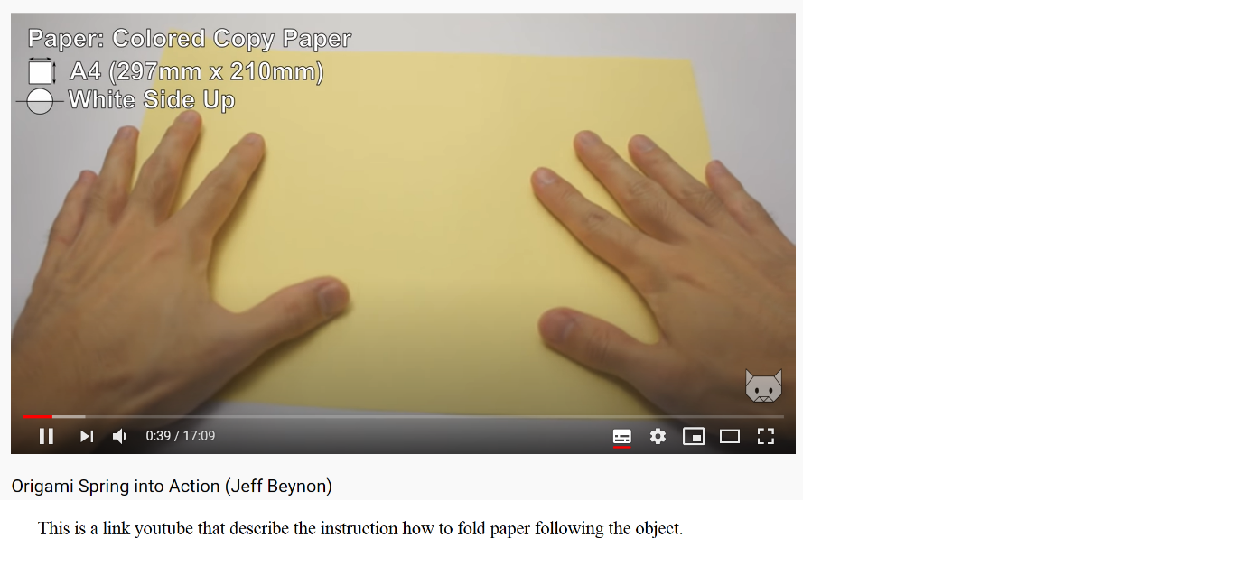

As you can see, when you click on the object that you really want to do, it will appear the link youtube how to fold the paper like that.

**NEWS**

**Description:**

In this section, the news is about the latest news of origami, such as the application of paper folding in human life, or the influence of the human spirit.

**Screenshot**

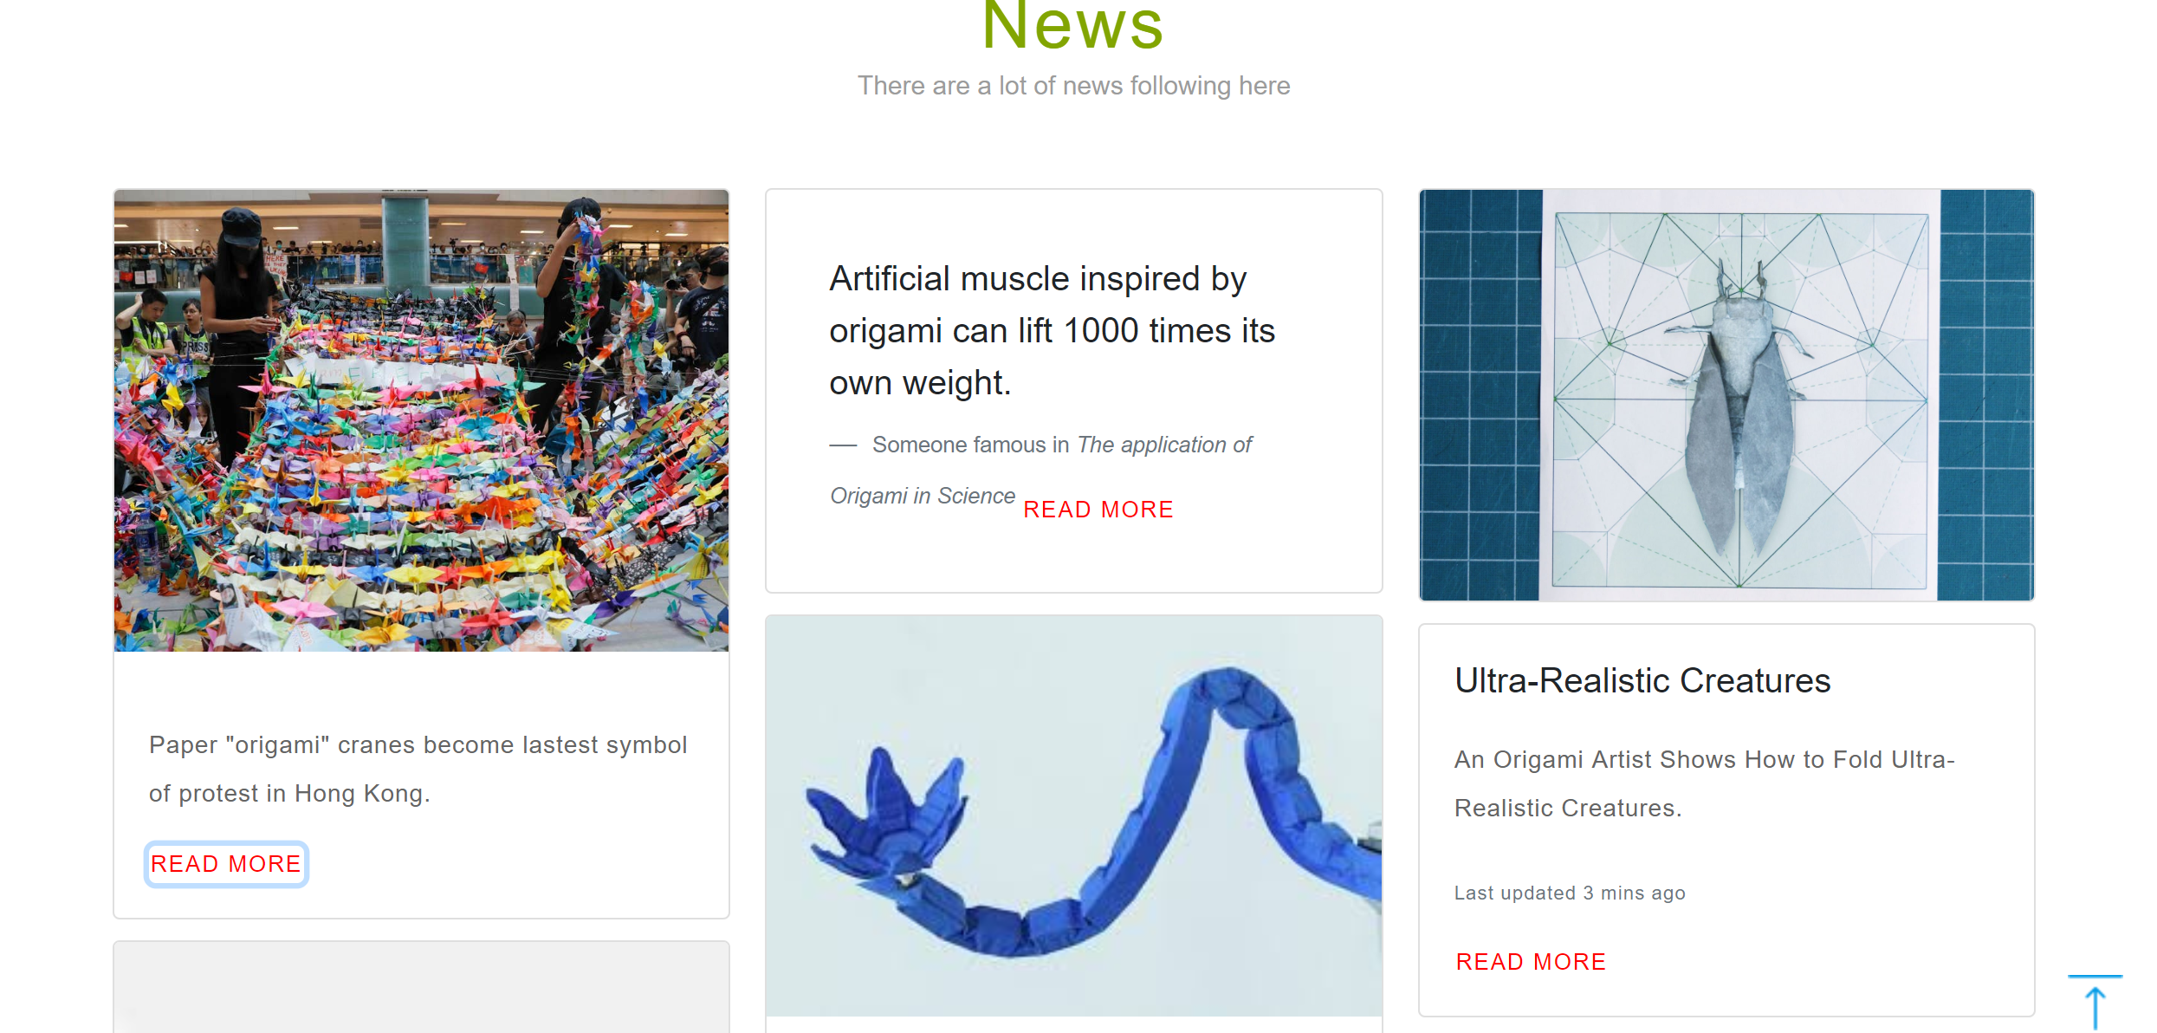

When you click READ MORE, it will displayed information about the news.

``````````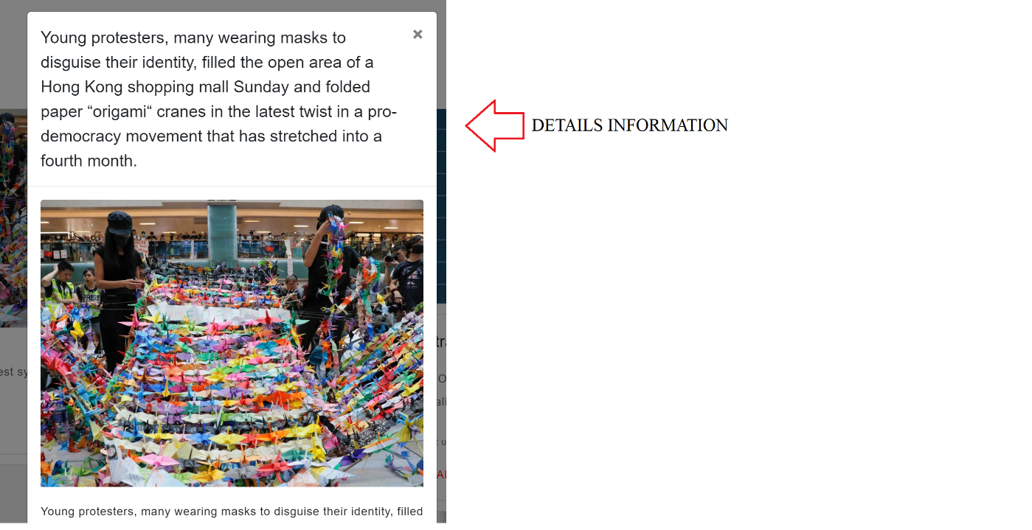

**ANOTHER PART:**

**Description:**

Also, we create the forms that describe information about our teams and the ways of creating origami by ourself. Finally, we have the motivation sentence to encourage your passion about making your origami object.

**Screenshot:**

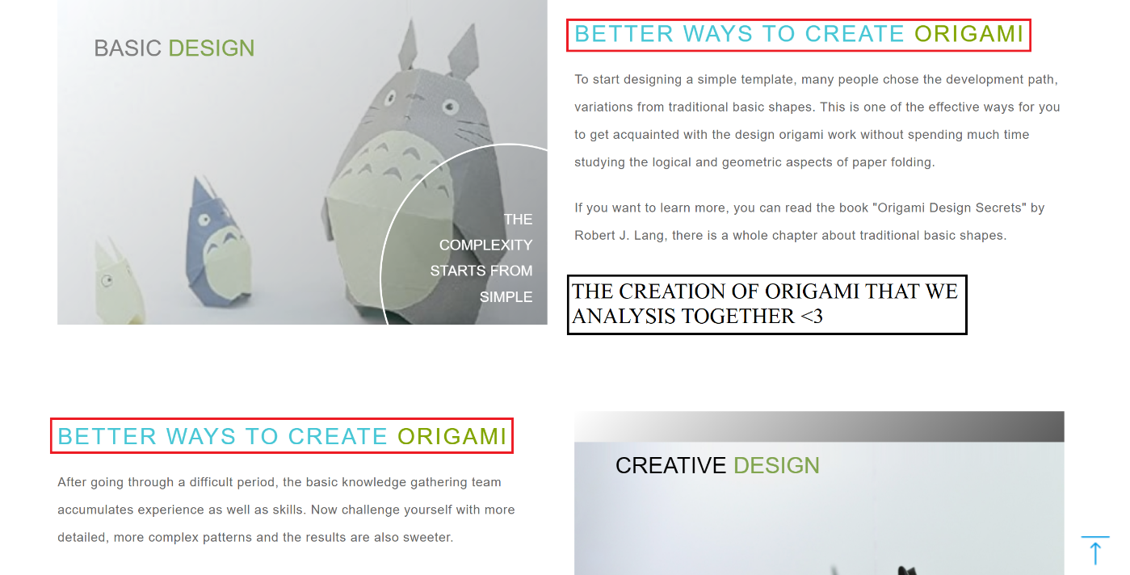

**THE MOTIVATION**

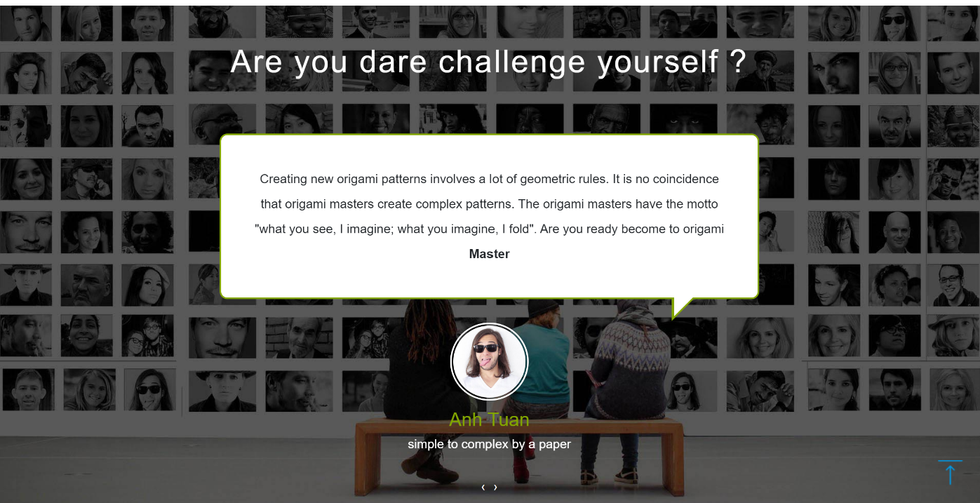

**OUR GREAT TEAM**

**Description:**

This is our team members, we have 3 members in our team including: Nguyen Anh Tuan – designer, Doan Nguyen Tuan Anh – developer and Nguyen Kim Hoang Nam – marketing. Everyone in my team have the important role to contribute and finishing to build the e-project. Also, if you guys want to contact each our members, you can access the following links on each of categories: Facebook, Twitter and Gmail.

**Screenshot:**

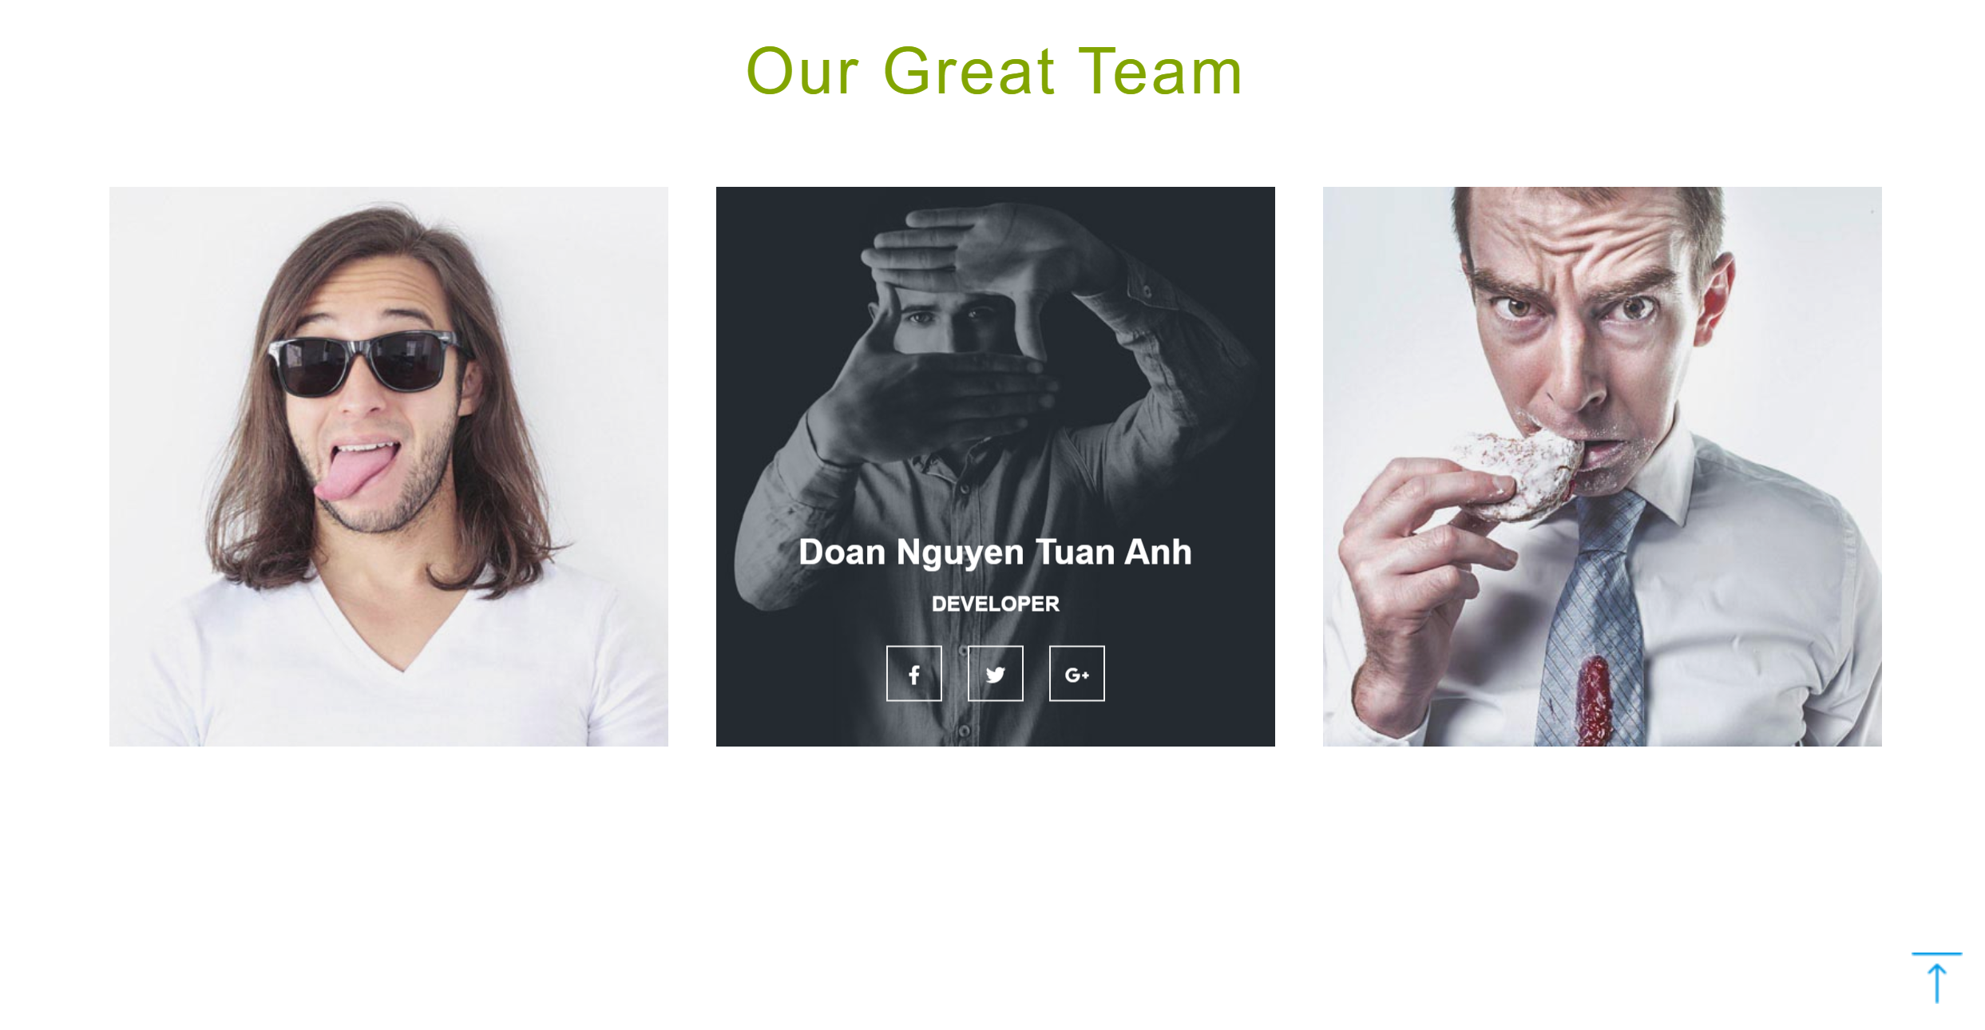

**CONTACT US:**

**Description:**

This webpage allows users to attend to contact with our team. In this part, we have the destination that we are working on and our phone numbers.

**Screenshot**

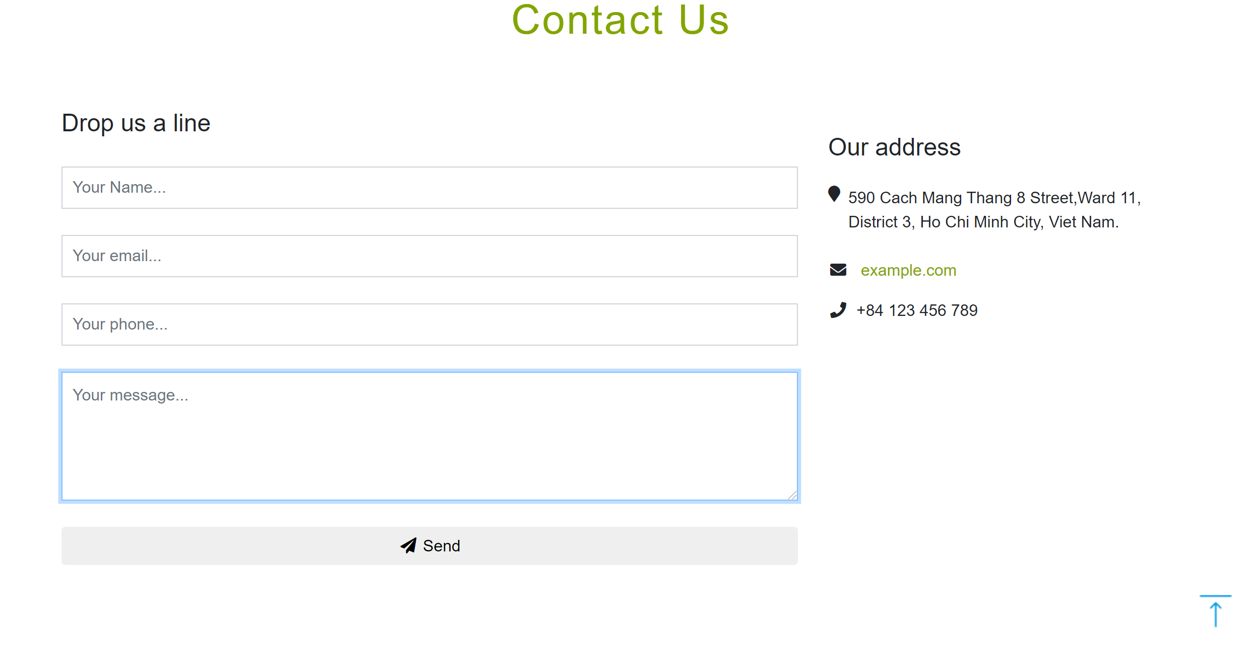

The users can fill up the form and contact with us like this.